W03-1: My ILO's
Let’s focus on the Intended Learning Outcomes (ILOs) in your own teaching. Please use this worksheet to individually formulate the ILOs for a future course or for a course that you planned or implemented in the past. Please think of one course in particular while formulating your ILOs.
a. What are topics that need to be addressed in this course?
b. What levels of understanding need to be achieved for each topic? (e.g. recalling facts, being able to judge something etc.)
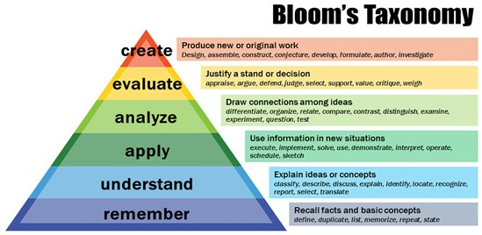
Vanderbilt University Center for Teaching (2016)
c. Formulate the intended learning outcomes for the selected topics and corresponding levels of understanding. You can use the verbs provided in the Bloom’s Taxonomy of Intended Learning Outcomes as a starting ponit (Vanderbilt University Center for Teaching, CC-BY-NC).
d. Prioritize the ILOs formulated. What are the ILOs that every single student needs to achieve? What are ILOs that are too specific given the anticipated previous knowledge of a certain group of students? Etc.
e. We assume that all co-teachers agree
f. How would you like to tell your students about the ILOs? Are you prepared to discuss the ILOs with them?
g. What Teaching and Learning Activities fit your ILOs/one of your ILOs? (only answer if you have finished no. 4 !)

