Didactic Concept
The GeoTraining specific goals includes different teaching/learning methods in order to foster diverse subject-specific and interdisciplinary competences. Besides addressing technical-methodological skills in handling environmental and remote sensing data by employing geospatial technologies in the field of biodiversity, ecology and conservation, the GeoTraining programme's offerings also include promoting relevant competencies in the areas of higher education didactics, general academic communication, and professional practices, as well as providing support and guidance. With regard to conveying interdisciplinary competencies, skills are fostered which consider dealing with complex knowledge, knowledge acquisition management, self-management, the presentation of professional knowledge, academic writing in English, and the ability to work as part of international teams.
The theoretical learning approach of the GeoTraining programme is based problem-based learning. Learning is viewed as an active, self-regulated, constructing, situational, and social process. Problem-based learning emphasizes the process character of learning and problem-orientation; both play a decisive role in the learning process. Within problem-based-learning, the objective of integrating the principles of content-related, situated learning, case-related, and authentic learning environments is being followed.
The GeoTraining programme is divided into the areas of geospatial technologies, learning in higher education didactics, academic communication and support and guidance. Furthermore, visits to vocational learning spaces and excursions are shown in relation to the areas of learning in terms of time sequence (see figure below).

GeoTraining programme schedule
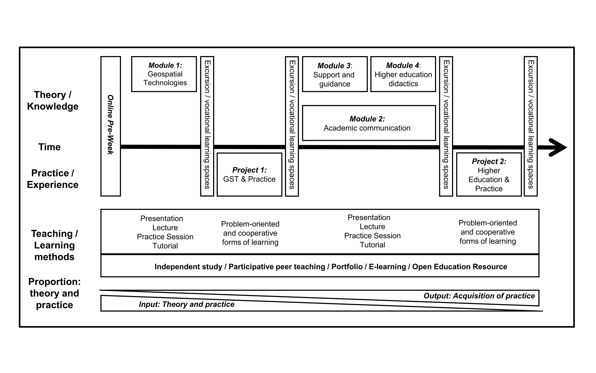
The two areas of learning are each subdivided into two separate session blocks, namely, the modules and the projects.
Each day, the modules' forms of events are organized into
- a lecture/presentation as an introduction to the topic;
- an exercise as a practical introduction to the topic, based on gradually synthesizing smaller parts of the problem (learner-centered, “learning by doing”), and
- tutorials offering support in doing homework and in revising and strengthening knowledge (learner-centered).

Two phases of project work
The resolution of a freely selectes subject-specific problem and a freely chosen higher education didactics problem is the center of the two phases of project work. Defined and known data records from the BIS-Fogo project are provided for the subject-specific project work, and material from the respective modules is used in the higher-education-didactics project work. Each team drafts a report indicating the conceptual and practical procedure. Based for the report, it is possible to distribute the workload evenly among the individual groups. The steps performed in the course of the project are organized, documented, and communicated to the course instructors by a predefined project management. The individual project results are displayed in the form of an academic poster, which simultaneously serves as the basis for evaluation. The evaluation is conducted according to a set of previously announced criteria. A poster presentation and award ceremony take place within the framework of a common closing event. The closing event is held at a prominent place on the Westend Campus of the Goethe University. Through this, the performance of the participants is also displayed publicly, and a subject-specific exchange beyond the group of participants and lecturers is guaranteed. The participants receive a certificate acknowledging their successful participation at the end of the advanced training programme.

Different demands for training
Even though the participants are divided into master’s and doctoral students, it is difficult to develop a concept addressing the different demands; furthermore, the individual requests of the participants should also be considered. The challenge of a heterogeneous group of participants is considered in the didactic concept of the GeoTraining programme, since the heterogeneity is viewed both as a welcome opportunity for individualized learning as well as a chance for group processes. This is also reflected in the superordinate forms of learning of the advanced training measure.

Independent study
During the GeoTraining programme tutorials, students have the opportunity to learn in small groups differentiated between knowledge levels. The individual demands for advanced training are addressed by offering the participants an “advance organizer”, which describes concise, preparatory organisational and learning aids and additional material for those hungry for more knowledge on different professional and cognitive levels.

Participative peer teaching
Another important tool for addressing the different demands for the GeoTraining is participative peer teaching. Here, the participants assume the role of a peer teacher (tutors and mentors) in practice sessions, tutorials, and projects and are therefore responsible for the collective acquisition of competences to a greater extent. Another aim of the participative peer teaching is achieving a changed feedback culture, in which peer teachers give feedback to other participants and to teachers, thereby further refining the GeoTraining programme in a participative manner.

E-portfolio
The e-portfolio primarily consists of a wiki. The students independently compile the included material and add descriptions. The e-portfolio serves to compile a collection of material meeting the demands of the individual participants, while ensuring that the participants reflect upon their individual learning process and that their learning progress and their competence development is made visible. The e-portfolios are supervised by the teachers and the tutors.

E-learning/open educational resource
In line with the superordinate forms of learning and the event implementation described previously, a training resource system in the form of an open educational resource (OER) is developed. The OER serves as a general point of contact for the GeoTraining programme. However, it primarily ensures that important basic knowledge is documented and provides assignments, tasks, and material, allowing the preparation and follow-up work on the subject matter to be performed independently of place and time. Moreover, the open educational resource can be used by the participants at their home universities and can be accessed worldwide.

